SIMATS ENGINEERING

CO3- AT2 - Design Task - Medium

COURSE NAME: Advance Wireless Communication Systems / 5G / 6G Communication Systems
COURSE CODE: ECA56

COURSE OUTCOME COVERED

CO: 3 - Design spectrum access strategies, waveform generation methods, and multiple access techniques for efficient wireless transmission systems. (BL6)

Assessment Tool Number : CO3_AT2 Assessment Tool Weightage : 35% Assessment Tool : Design Task
Duration : 180 Minutes
Marks : 100 Marks
Type of Assessment Conduction : At Home Evaluation Type : GitHub
Result Generation : Students design and justify appropriate wireless
communication solutions by applying engineering principles to meet specified requirements.
Topic Covered :
Spectrum management, licensed/unlicensed spectrum, dynamic spectrum access, cognitive radio, OFDMA, resource block allocation, GFDMA, NOMA, power- domain multiplexing, SIC, and IoT applications. Advanced waveforms and wireless technologies including GFDM, FBMC, UFMC, mmWave propagation, path loss and penetration, millimeter-wave antenna systems, MIMO, and Massive MIMO fundamentals.

Short description about assessment: Students design a system / model based on given requirements to assess creativity and application skills. This question paper consists of a total of 40 questions, out of which each student is required to answer any 2 questions. Each question carries 50 marks, and the paper carries a total of 100 marks

QUESTIONS: 2 (2 X 50 = 100) Total Marks: 100 Duration: 3
Code of Conduct:

I (Name / Reg No) certify that this submission is my original work and that I have adhered to the guidelines specified for this assessment.
I understand that any violation of academic integrity rules will result in disciplinary action.

Signature of the student:

RUBRICS FOR CALCULATION:

Design Task
Criteria | Weightag e | Level 4 (Exemplary) | Level 3 (Proficient) | Level 2 (Developing) | Level 1 (Beginning)
Understanding of Design | 20% | Demonstrates deep understanding of design objectives, constraints,  and context | Shows good understanding with minor gaps | Partial understanding; misses key aspects | Lacks understandin g of the design context
Evaluation of Design | 25% | Provides in-depth critique identifying strengths, weaknesses, and design  gaps | Identifies key issues with reasonable analysis | Limited critique; mostly descriptive feedback | No meaningful critique provided
Justification | 20% | Supports critique with strong reasoning, evidence, and relevant  principles | Provides justification with some supporting evidence | Weak or unclear justification | No justification for feedback
Suggestions for Improvement | 20% | Offers innovative, practical, and well-justified improvement suggestions | Provides useful suggestions with minor gaps | Suggestions are limited or partially relevant | No constructive suggestions provided
Communicatio n | 15% | Communicates feedback clearly, professionally, and engages actively in  discussion | Communicates well with minor issues | Communication lacks clarity or engagement | Poor communicatio n and minimal participation

- System Architecture for Multi-access Edge Computing (MEC) to Reduce Latency in Smart Traffic Applications

Objective
To design a Multi-access Edge Computing (MEC) architecture that processes traffic data close to vehicles and roadside devices, thereby reducing communication latency and enabling real-time traffic management.

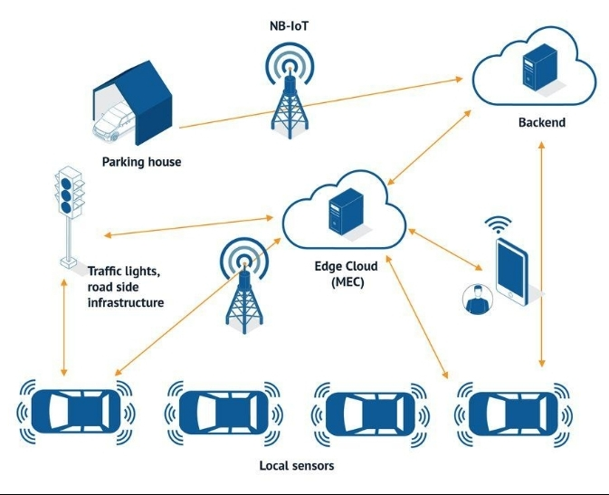

Working
Data Collection:
Cameras, traffic sensors, GPS devices and connected vehicles collect traffic information such as vehicle speed, density and road conditions.
5G/V2X Communication:
The collected data is transmitted through 5G or V2X communication to the nearest MEC server.
Edge Processing:
Instead of sending all data to a distant cloud, the MEC server processes the information locally.
Real-Time AI Analysis:
AI/ML algorithms at the edge detect traffic congestion, accidents and abnormal traffic conditions.
Traffic Decision:
The MEC server can determine whether traffic signals should be changed, alternative routes suggested, or emergency vehicles given priority.
Fast Response:
Decisions are sent immediately to traffic controllers, RSUs and vehicles.
Cloud Coordination:
Important or historical data is forwarded to the cloud for long-term storage, large-scale analytics and AI model training.
Advantages
Low communication latency
Real-time accident detection
Faster traffic signal control
Reduced cloud bandwidth consumption
Improved road safety
Better congestion management
Supports autonomous and connected vehicles
Scalable for smart-city applications
Conclusion
The proposed MEC architecture places computation near the traffic sources. 5G/V2X + MEC + IoT + AI enables rapid processing and decision-making, making it suitable for intelligent traffic signals, accident detection and connected-vehicle applications.

- Cloud-Edge Communication Model for Wireless Healthcare Monitoring

Objective
To develop a cloud-edge communication model that enables continuous monitoring of patients using wireless sensors while providing fast local responses and cloud-based medical analysis.
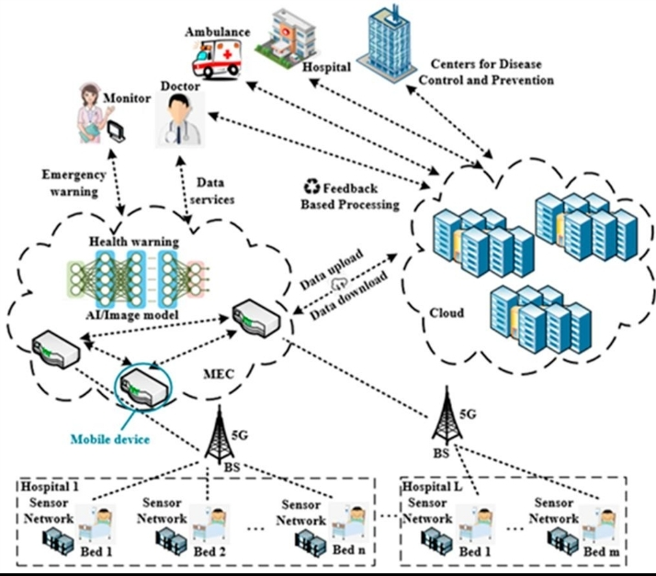

Working
Wireless Data Collection:
Wearable sensors continuously measure parameters such as heart rate, SpO₂, body temperature and blood pressure.
Patient Gateway:
Sensor data is transferred using Bluetooth, Wi-Fi or another wireless connection to a smartphone or IoT gateway.
Edge Processing:
The nearby edge server performs immediate processing of the patient's data.
Abnormality Detection:
Edge AI analyzes the data and detects potentially abnormal conditions.
Emergency Response:
If a critical condition is detected, an alert can be sent immediately to medical staff or caregivers without waiting for cloud processing.
Cloud Communication:
Patient data and selected results are transmitted to the cloud through the Internet/5G.
Cloud Analytics:
The cloud stores historical patient information and performs large-scale analytics and AI/ML model training.
Doctor/Healthcare Access:
Authorized healthcare professionals can access patient information through a secure web or mobile application.
Cloud vs Edge Processing
Parameter
Edge
Cloud
Processing location
Near patient
Remote data center
Response time
Very low
Higher
Real-time alerts
Excellent
Depends on network
Long-term storage
Limited
High
Large-scale analytics
Limited
Excellent
Bandwidth requirement
Lower
Higher

Advantages
Real-time patient monitoring
Faster emergency alerts
Reduced network latency
Reduced cloud bandwidth
Continuous remote monitoring
Historical data storage in cloud
AI-based abnormality detection
Better scalability for multiple patients
Security Requirements
Because healthcare data is sensitive, the system should use:
Authentication
Encryption during communication
Secure patient identification
Access control
Secure cloud storage
Privacy-preserving data processing
Conclusion
The proposed cloud-edge communication model combines the fast response of edge computing with the storage and computational capabilities of cloud computing. It is suitable for remote patient monitoring, emergency detection and intelligent healthcare systems, particularly when low latency and reliable wireless

